**Tên: Nguyễn Như Khoa**

**MSSV: 31211025536**

**LAB 4.1 Part 1**

**4-1MA**

**4-1MB**

**OQ1.** Imperial Stout is the top-selling product based on total revenue.

**OQ2.** Imperial Stout generated a total revenue of $370,440.

**OQ3.** Texas had the highest total revenue overall.

**OQ4.** Texas generated a total revenue of $294,440

**LAB 4.1 Part 2**

**4-1MC**

**4-1MD**

**OQ1.** The total sales volume for January 2020 is 2295 units.

**OQ2.** Slainte exceeded its sales volume target by 2380 (more than 10000) units by selling 12380 units in total

**OQ3.** In February 2020, Imperial Stout, IPA and Stout were sold over 300 units.

**OQ4.** Slainte missed its sales goal by 1814 units (by selling 8186 units so far).

**LAB 4.2:**

**4-2MA**

**4-2MB**

**OQ1.** Beverage Distributors is the largest customer in Iowa.

**OQ2.** 14 customers reside in Texas.

**OQ3.** Pale Ale has the most uncertain forecast.

**OQ4.** The trend in the forecast for sales overall relative to March is $78,225.

**OQ5.** Descriptive analytics is used to represent the Sales Revenue by Customer visualization.

**OQ6.** Predictive analytics is used to represent the Sales Revenue Forecast visualization

**LAB 4.3 Part 1:**

**4-3MA**

**OQ1.** The total loan amount is $3,503,840,175.

**OQ2.** The median loan amount is $13,000.

**OQ3.** The median interest rate is 0.1365.

**OQ4.** The median DTI is 17.63

**OQ5.** The data cards utilize descriptive analytics

**LAB 4.3 Part 2:**

**4-3MB**

**OQ1.** 58.39% of the loans have a 36-month term.

**OQ2.** Most borrowers have a mortgage.

**OQ3.** January to June have the most non-volatile volume of loans.

**OQ4.** Borrowers with a higher debt-to-income ratio tend to have smaller loans.

**LAB 4.4 Part 1:**

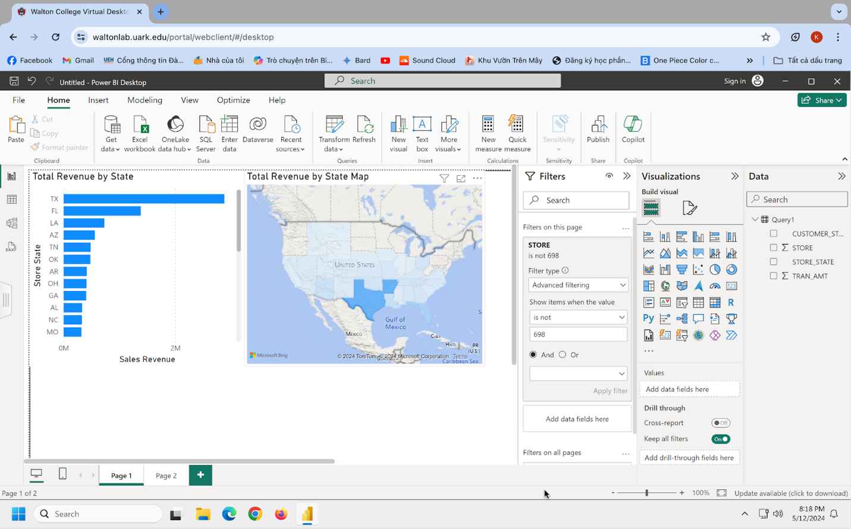

**4-4MA**

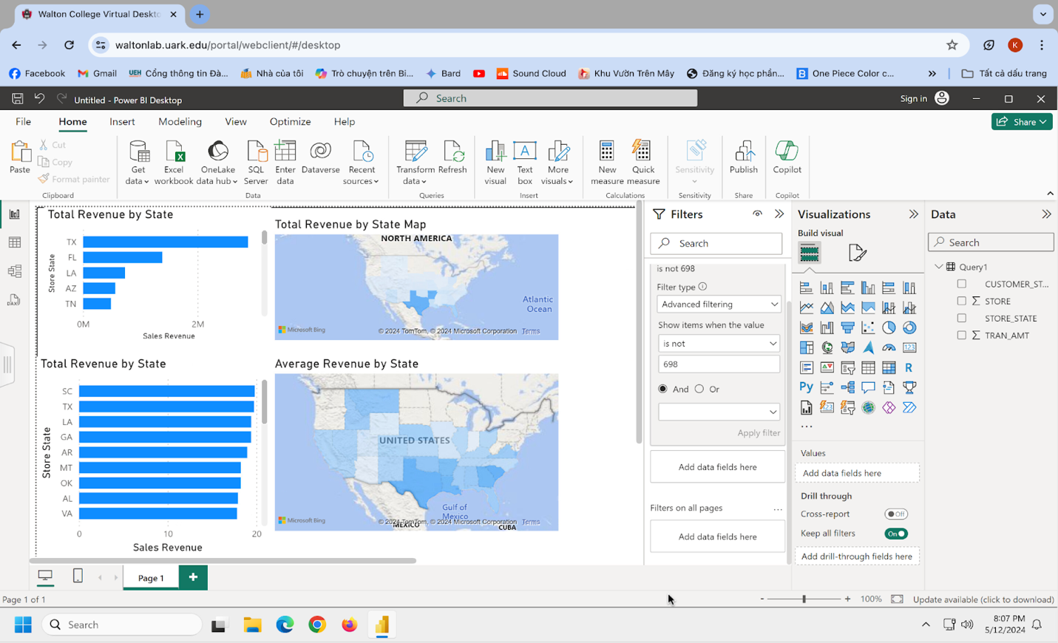

**4-4MB**

**OQ1.** WY is the state having the lowest sum of transaction amount.

**OQ2.** TX is the state having the highest sum of transaction amount.

**OQ3.** The average transaction amount for Montana (MT) is 18.23.

**OQ4.** The average transaction amount for in-person transaction in Arkansas (AR) is 18.95

**OQ5.** Descriptive analytics is represented in these visualizations.

**LAB 4.4 Part 2:**

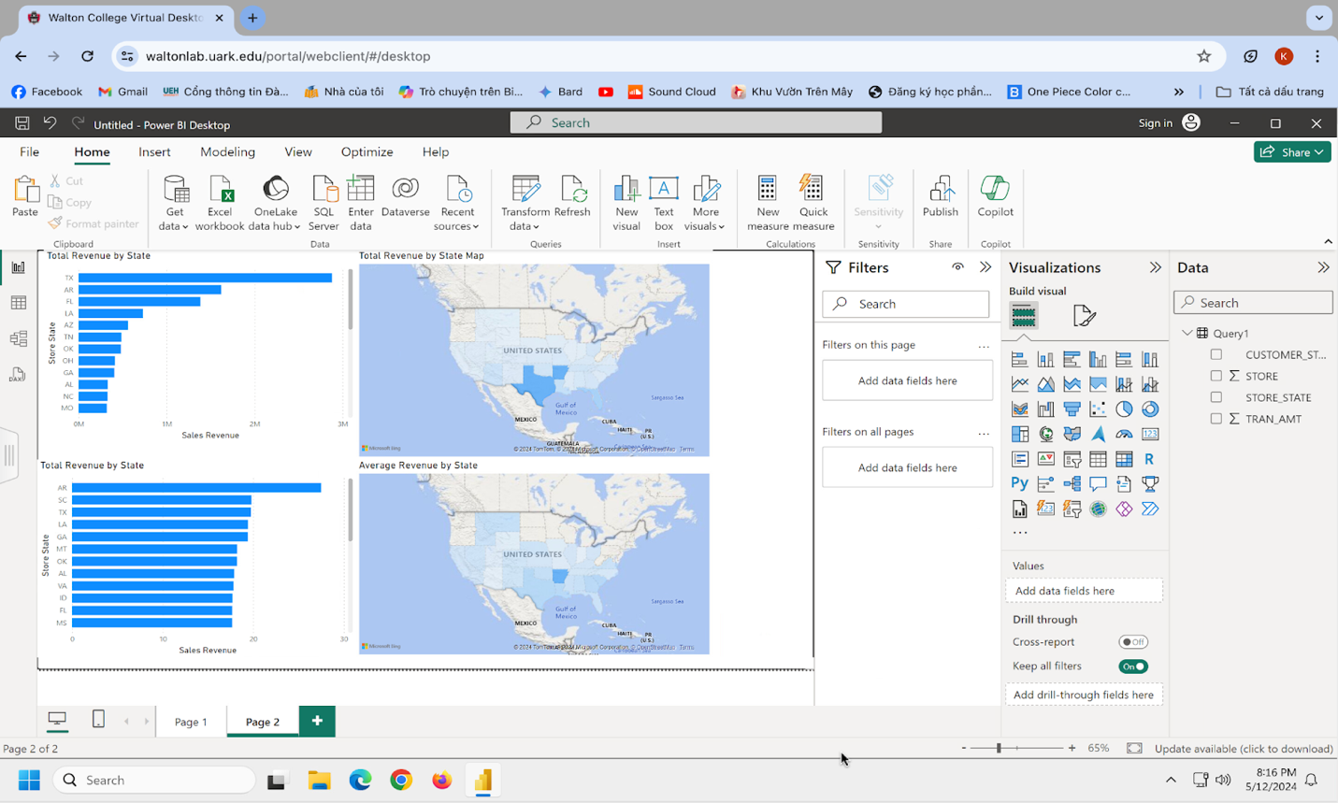

**4-4MC**

**OQ1.** 33.19.

**OQ2.** 1,758.15.

**OQ3.** Average online transaction amount for customers fom Texas greater than average transaction amount from stores located in Texas (32.00>19.75).

**LAB 4.5 Part 1:**

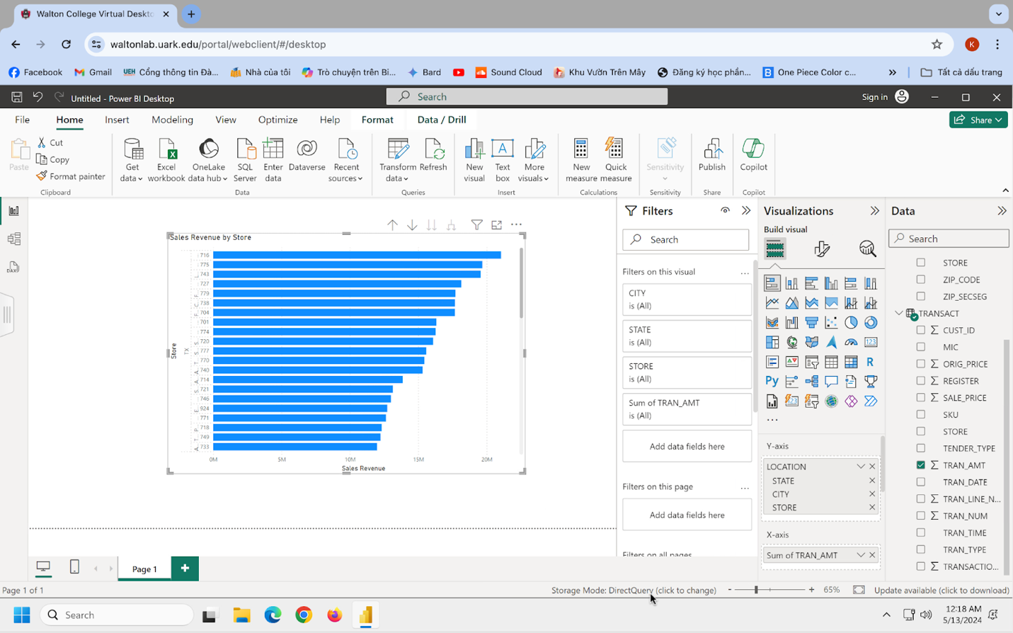

**4-5MA**

**OQ1.** TX Dallas is the store that has the highest sum of transactions located in.

**OQ2.** TX Houston has the most stores.

**OQ3**. Descriptive analysis.

**LAB 4.5 Part 2:**

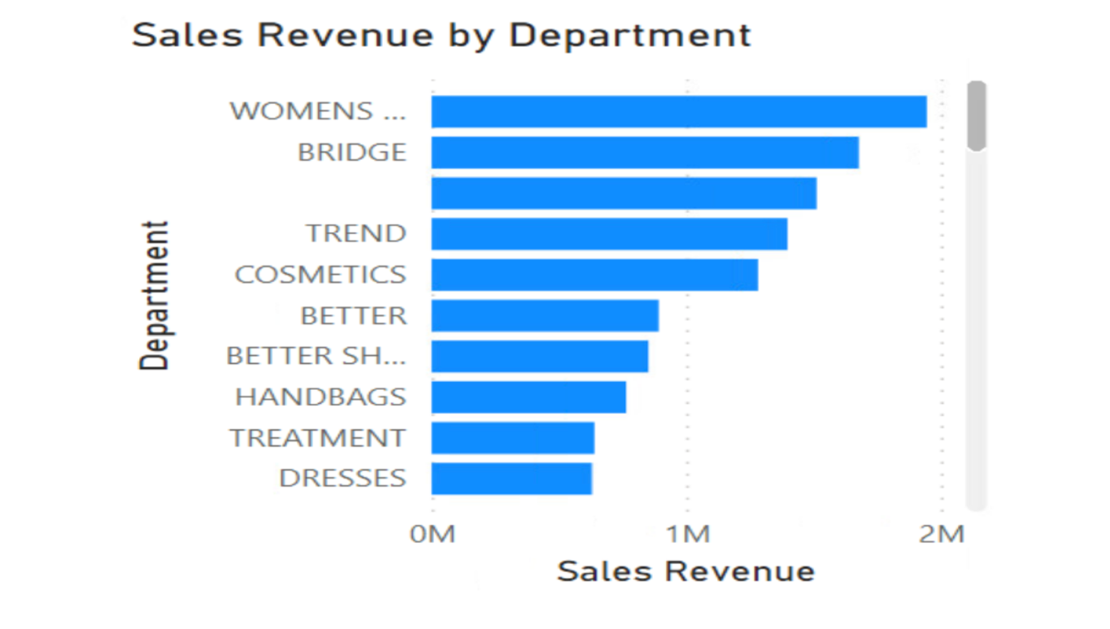

**4-5MB**

**OQ1.** Women's shoes are the best selling in the Shoes Century.

**OQ2.** Juniors are the worst performing.

**OQ3.** Bedroom is the best selling in the Big Ticket (Century) > Case Goods (Decade)